**Meeting:** Eleventh Official Sponsor Meeting

**Date:** 04th October 2016

**Location:** B3 Bistro

**Attendees:** Wendy, Weilun, Zongwei, Gaomin

Sponsors – Mr Edmund, Mr Marcus

**Absentees:** Chingyi

**Minutes Prepared by:** Wendy

**Vetted by:** Weilun

**Points to Note**

1. Update on sync function: on/off, will not delete from phone
2. Registration will have these fields: username, password, confirm password, email, admin pin and phone number to trace
3. Update on current iteration plan: fingerprint/admin pin authentication:

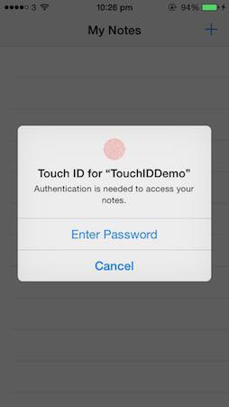

1. Update on next iteration: User guide (additional)
2. UAT 2: come up with user testing goals/plans (time taken)
3. Migration of parse: 5th Oct 2016 (1400-1800 at B3)
4. Send language word documents (Malay and Tamil)
5. Checkout Quik/Tablue for backend admin dashboard displaying of inactive users
6. Add COGS and expenses in BI
7. Discuss and agreed to upgrade to ios10

Meeting is adjourned at **1700**.